**Birla Institute of Technology & Science, Pilani**

**Work Integrated Learning Programmes Division**

**Second Semester 2023-2024**

**Mid-Semester Test**

**(EC-2 Regular)**

Course No. : CSI ZG518

Course Title : Database Design and Applications

Nature of Exam : Closed Book

Weightage : 30%

No. of Pages = 3

No. of Ques = 4

# No. of Questions = 4

Duration : 2 Hours

Date of Exam : 17/03/2024 (AN)

Note to Students:

1. Please follow all the *Instructions to Candidates* given on the cover page of the answer book.
2. All parts of a question should be answered consecutively. Each answer should start from a fresh page.
3. Assumptions made if any, should be stated clearly at the beginning of your answer.
   1. Convert the ER to Relational Schema.

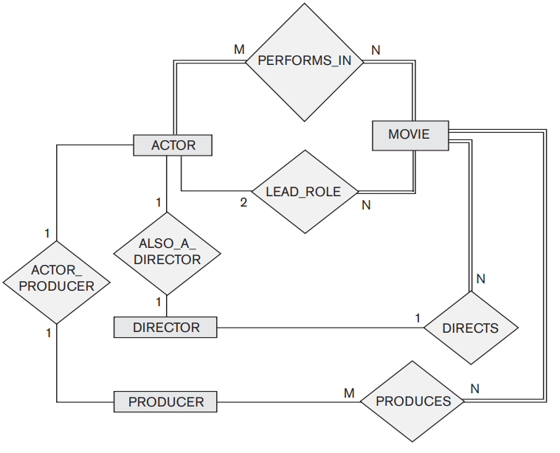

**Grading:**

Entities, attributes and PK: **2 marks**

Relationship: **2 marks**

Referential Integrity Constraints: **2 marks** **Total marks:6 marks**

1. Consider the relation **R(M, N, O, P)** with functional dependencies **F**:

**F = {M → N, NO → P, P → O}**

(a) Decompose the relation **R** into BCNF, explaining each step of your process.

(b) Ensure that the decomposition preserves functional dependencies and is a lossless join.

**(4 marks)**

1. Given a relation schema **S(P, Q, R, S, T)** with functional dependencies **G**:

**G = {PQ → R, R → S, S → T, T → PQ}**

(a) Decompose the relation **S** into relations that are in BCNF. Describe each step.

(b) After decomposition, check if all original functional dependencies are preserved.

**(4 marks)**

**Total marks: 8 marks.**

1. Given functional dependencies for relation **R (G, H, I)** :

* G → H
* H → I
* I → G
  + 1. Find all candidate keys and prime attributes for **R**.
    2. Find the minimal cover for the given functional dependencies.
    3. Decompose **R** into 3NF.
    4. Decompose **R** into BCNF, ensuring it is a lossless join decomposition.
    5. Check if the functional dependencies are preserved after decomposition.

**Total marks: 8 marks.**

1. Answer the following for the Company Relation Schema

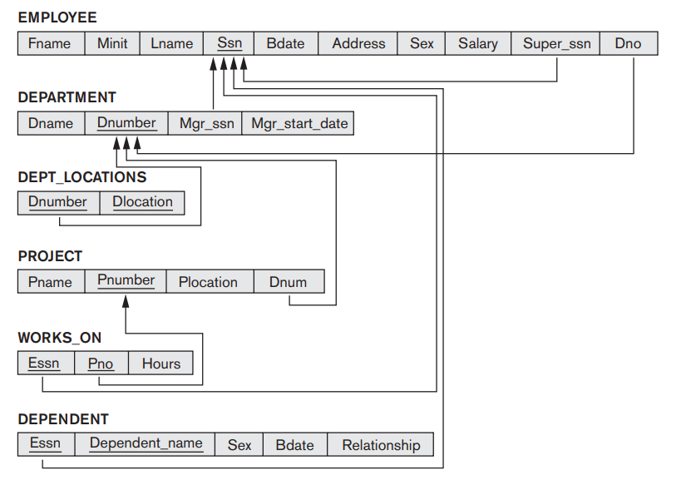

1. **Write RA and SQL query** to list the names of managers who started on or after January 1, 2020.
2. Construct **an SQL query** to find the top three departments with the highest number of employees working on projects, including the department name, number of employees, and the names of the projects.
3. Design an **SQL query** to list all managers’ names who have a dependent with the same name.
4. Formulate an **SQL query** to retrieve a list of employees who do not work on any project located in their department's location. Output includes the employee's name, department name, and project location.
5. Write an **SQL query** to find employees who live in the same address as a manager but are not managed by them.
6. **Write RA and SQL query** to retrieve the names of employees who work on more than one project.

**Total marks: 8 marks**

=======